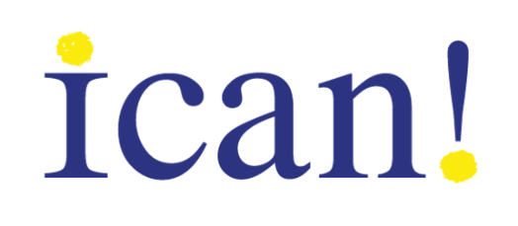
ICAN! Community Based Organization (CBO) Request for Project Support

Illinois Contraceptive Access Now (ICAN!) is a statewide initiative to advance reproductive health equity by improving the quality and coverage of contraceptive care. ICAN! seeks to create a national model for establishing high-quality contraceptive care as an essential and routine part of whole-person preventive and primary care by supporting community health centers to deliver patient-centered contraceptive care, empowering patients to seize their right to the highest quality care, and by removing financial barriers through innovative policy reform.
Community partners play a pivotal role in helping to create a “community ecosystem” focused on ensuring that patients receive contraceptive care that is timely, dignified, culturally sensitive, free of coercion, and evidence based.
To support maternal, child, reproductive, and community health organizations in promoting and offering contraceptive information and care referrals to individuals most in need, ICAN is offering small funding requests for up to $2,000. Requests are reviewed by the ICAN! Community Advisory Board with priority given to organizations that successfully demonstrate a commitment to educating, engaging, and empowering the individuals they serve to realize their human right to achieve a state of reproductive well-being. Funding requests are needs-based and subject to availability.
Examples of proposed activities include but are not limited to:
- Developing and deploying relevant training materials to support community organization staff to provide patient-centered contraceptive information and referrals.
- Creating branded or co-branded assets to support client outreach, such as the range of FDA-approved methods of contraception, youth rights to contraception, etc.
- Supporting outreach, community mobilization, or volunteer engagement around contraceptive care and reproductive well-being.
- Social media engagement or marketing that elevates trauma-informed, respectful, unconscious-bias aware and evidence-based contraception information and services.
To apply for funding, please complete and return the form below. Funding requests are reviewed on a rolling basis in the order in which they are received. Please direct any questions to Dr. Toni M. Bond at tbond@alliancechicago.org.
Applicant information
Name
Email
Phone Number
Organization information
Name
Address
Mission
Population(s) served
County(ies) served
Proposed project
Background of the problem you are trying to address:
Proposed solution of the problem you are addressing, including three measurable outputs:
Please provide three measurable anticipated project outcomes and how they will be measured. Please include anticipated number of people who will be reached.
Proposed budget
Amount requested
2021 organizational budget
Top three budget line items with amount requested:

